Proposal Task

Optimus Prime, leader of the Autobots, has chosen your robot to join his team of elite androids. They are looking for a navigator, capable of finding a target, and exiting the premises as quickly as possible. Your robot’s skills must be put to the ultimate test. Go big, or Motor.A.GoHome( );

This culminating proposal is for Yusuf Kokar in the Lego NXT Lejos program. The robot is initially confined in a puzzle room! Start the robot at the sound of a clap. On clap, the robot must drive forwards. Using the ultrasonic sensor, make sure the robot does not run into any objects or walls. The robot must successfully find a white circle on the floor; do a full spin, than promptly exit the room.

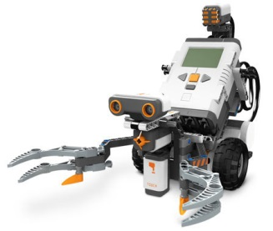

Materials:

-Scissors   
-Tape   
-Large cardboard box  
-Obstacles   
-cardboard  
-White out

**Exit**